Walter Piper

Springboard Capstone 2

WESAD dataset – Meditation and social stress

**Problem identification / Introduction**

Social stress is an inevitable part of life and of a professional career. However, uncontrollable social stress is also linked to poor health outcomes.

Wearable devices that track heart rate or other physiological variables have become commonplace in recent years. Although these wearables were first purposed for fitness, they are ideal for studying certain aspects of the mind-body connection due to their ability to index the autonomic nervous system.

The autonomic nervous system, which we cannot directly control, can be thought of as the body’s energy management infrastructure. There are two major subdivisions. The sympathetic nervous system (SNS) mobilizes energy stores when high-energy consumption is expected, an effect sometimes referred to as the “fight-or-flight response”. Providing a counterbalance, the parasympathetic nervous system (PNS) encourages energy storage, sometimes called the “rest-and-digest response”.

Importantly, these autonomic responses often occur upon exposure to salient stimuli. For example, an immediate threat to our safety will often activate the SNS (the “fight-or-flight response”).

For better or worse, evolution has seen fit to tune these responses to social situations. A loss of social status may very well impact our ability to survive and provide for loved ones, so the body processes this similarly to a physical threat.

Unfortunately, the high sensitivity of this system is often inappropriate for our modern world. For many of us, our social world is a hive world, characterized by frequent interactions with strangers. We are not directly dependent on the majority of people we meet, which is a recent phenomenon in the whole of human history. Our evolution has not caught up, so we must make efforts to contain our hyperreactive autonomic nervous system.

These efforts to contain our reactions to social stress take many forms, but one approach that has widespread support from scientific, self-help, and religious communities is meditation. Another common approach is humor, or amusement. This investigation seeks to determine if meditation and/or amusement are capable of alleviating psycho-biological stress responses in stressful social situations.

**Dataset description**

The [Wearable Stress and Affect Detection (WESAD) dataset was obtained from UCI’s Machine Learning Repository](https://archive.ics.uci.edu/ml/datasets/WESAD+%28Wearable+Stress+and+Affect+Detection%29) (Schmidt et al., 2018). The data comes from 15 participants going through a nearly 2-hour procedure with several distinct task segments. The segments were baseline, social stress, amusement, and 2 rounds of paced-breathing meditation. Eight of the participants went through amusement and meditation before social stress, while the other 7 went through social stress after the initial baseline. The Trier Social Stress Task was used as the stress task, which requires participants to give a presentation and perform mental arithmetic in front of judgmental strangers (Allen et al., 2017).

This dataset contains 3 categories of data. The first category of data was electrical sensor data from 2 devices. The first device was a RespiBAN Professional that was placed on the chest and collected accelerometer readings, respiration, electrocardiogram (ECG), electrodermal activity, electromyography (EMG) recorded from the subjects’ upper trapezius muscles, and temperature readings. All data from the RespiBAN device were recorded at 700Hz. The other device was a Empatica E4 that was placed on the wrist and measured blood volume pulse (64Hz), electrodermal activity (4Hz), temperature readings (4Hz), and accelerometer readings (32Hz).

The second category of data came from self-report questionnaires administered after each task segment. These were derived from various affective scales that used ordinal values. These included the ‘Positive and Negative Affect Schedule’, ‘State-Trait Anxiety Inventory’, ‘Self-Assessment Manikins’ for arousal and valence, and the ‘Short Stress State Questionnaire’. Although all values were analyzed during exploratory data analysis, the final modeling used arousal and valence values from ‘Self-Assessment Manikins’ because most other measures were redundant with these 2 measures. This was beneficial for both reducing dimensionality and for interpretation.

The third and final category of data was subject-level measures, obtained at the start of the experiment. These measures included height, weight, sex, age, and whether the participant recently exercised, drank coffee, or smoked cigarettes.

**Data wrangling**

The 3 categories of data were loaded and examined visually. The sensor data and the subject data had no missing values, and the affect questionnaires only had 1 missing value that had no effect on the analysis presented here. A label channel (shown below) showed the task segments in the two different experimental conditions, one with stress before meditation/amusement (left plot), and one with meditation/amusement before stress (right plot).

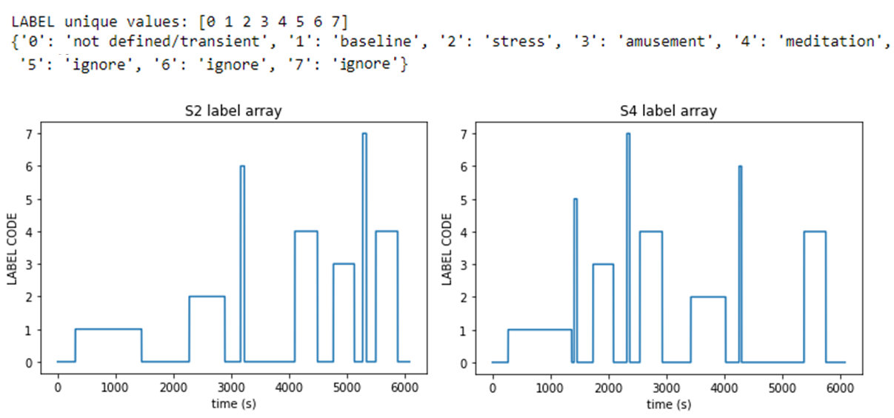

For each participant, histograms were obtained for each channel of sensor values. Due to the large sample size (over 4 million time points), 10,000 time points were sampled to construct each histogram.

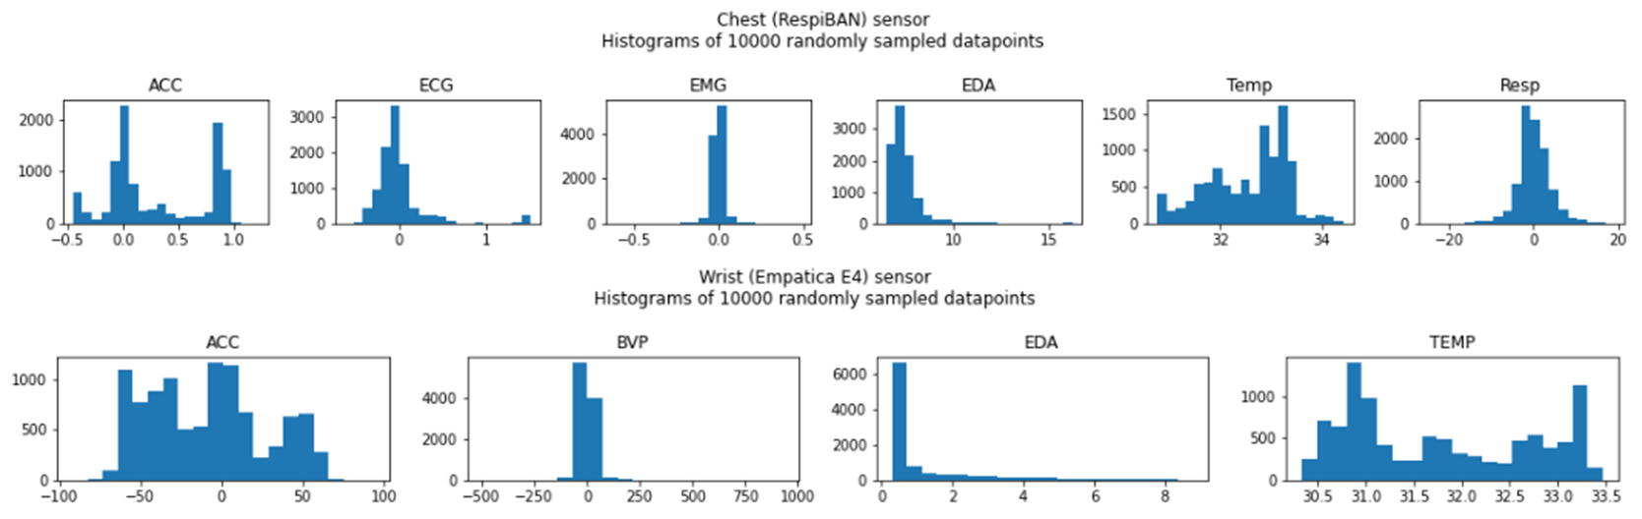

**Preprocessing transformations**

Each sensor channel needed to be transformed to get meaningful aggregate values.

Heart beat timing was extracted from the ECG channel by using the ‘[BioSPPy](https://biosppy.readthedocs.io/en/stable/)’ biosignal processing package for Python to run a Hamilton segmentation algorithm. Afterwards, the ‘[BQPlot](https://bqplot.readthedocs.io/en/latest/api_documentation.html)’ package was used to create an ipywidget-based interactive GUI to clean the heart beat times, allowing insertion of beats missed by the Hamilton algorithm and removal of false positives. The result was an array of heartbeat times and interbeat-intervals. The interbeat intervals are inversely proportional to heart rate, so these values were later used during segmentation to determine heart rate and heart rate variability.

Electrodermal activity was analyzed to extract events of sweat release from pores, also known as galvanic skin responses (GSR). The chest RespiBAN sensor readings were downsampled from 700Hz to 4Hz using median-based aggregation. The data was then differenced to get a stationary signal, and the [find_peaks function from SciPy](https://docs.scipy.org/doc/scipy/reference/generated/scipy.signal.find_peaks.html) was used with a peak_prominance keyword value that was titrated to find between 200 and 500 total events for each participant.

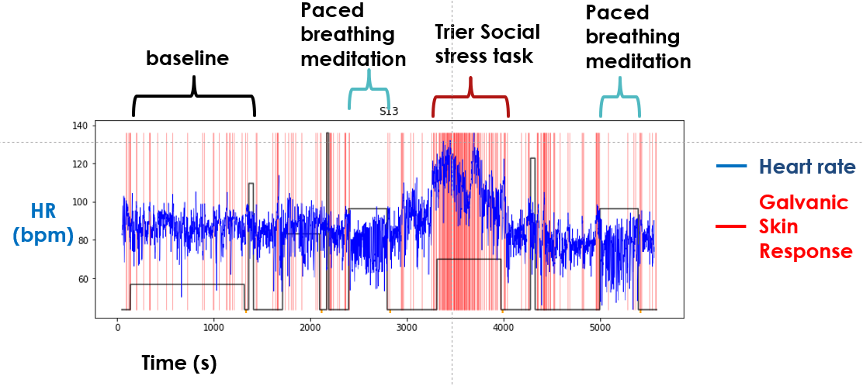

EMG data from the subjects’ upper trapezius muscles were run through a high-pass filter (using Scipy’s [firls](https://docs.scipy.org/doc/scipy/reference/generated/scipy.signal.firls.html) and [filtfilt](https://docs.scipy.org/doc/scipy/reference/generated/scipy.signal.filtfilt.html) functions) to keep oscillations faster than 32Hz. The filtered data was squared to make all values positive then downsampled from 700Hz to 20Hz in order to clearly distinguish activity from inactivity.

Accelerometer data from the chest RespiBAN device were transformed to extract the energy of moment-to-moment changes. Because some accelerometer readings appeared to get stuck at non-zero values between periods of movement, the 3 channels (one for each axis in 3-dimensional space) were differenced to ensure stationarity then squared and downsampled from 700Hz to 10Hz to clearly distinguish activity from inactivity.

Accelerometer data from the wrist Empatica E4 device were treated similarly, except they were downsampled from 32Hz to 8Hz.

Respiration data was downsampled from 700Hz to 10Hz.

Blood volume pulse data was downsampled from 64Hz to 16Hz, but this data was largely redundant with ECG data and was not used in subsequent analysis.

**Segmentation**

Each physiological measure was aggregated over entire task segments, which allowed clean comparisons of these physiological measures with affective questionnaires that were delivered at the end of the tasks. Due to the diversity of physiological signals, the aggregation computation was different for different measures. The task segments were identified by detecting the edges of the square waves of the label channel.

Average heart rate was simply calculated by dividing 60 (seconds/minute) by the interbeat interval (in seconds), resulting in an averaged beats per minute. Heart rate variability (HRV) was calculated by taking the root mean square of successive differences in interbeat intervals. The average rate of galvanic skin responses were obtained by dividing the count of skin response events by the length of the task segment. The average power of EMG and accelerometer recordings were all obtained by averaging the previously obtained smoothed power values. Respiration was aggregated in a more complex way in order to index respiratory coherence/consistency, consisting of taking the autocorrelation function of the smoothed 10Hz respiration values, then squaring the autocorrelation function and summing over the first 7,000 lags.

**Exploratory data analysis**

The aggregated values are shown below for each task segment across all 15 participants. Some findings are clear from this visual inspection. The social stress test clearly invoked high heart rate and high rates of galvanic skin responses (electrodermal activity), as well as movement shown by the accelerometer power. The paced-breathing meditation task, as expected, involved more consistent respiration than other tasks and slightly higher heart rate variability.

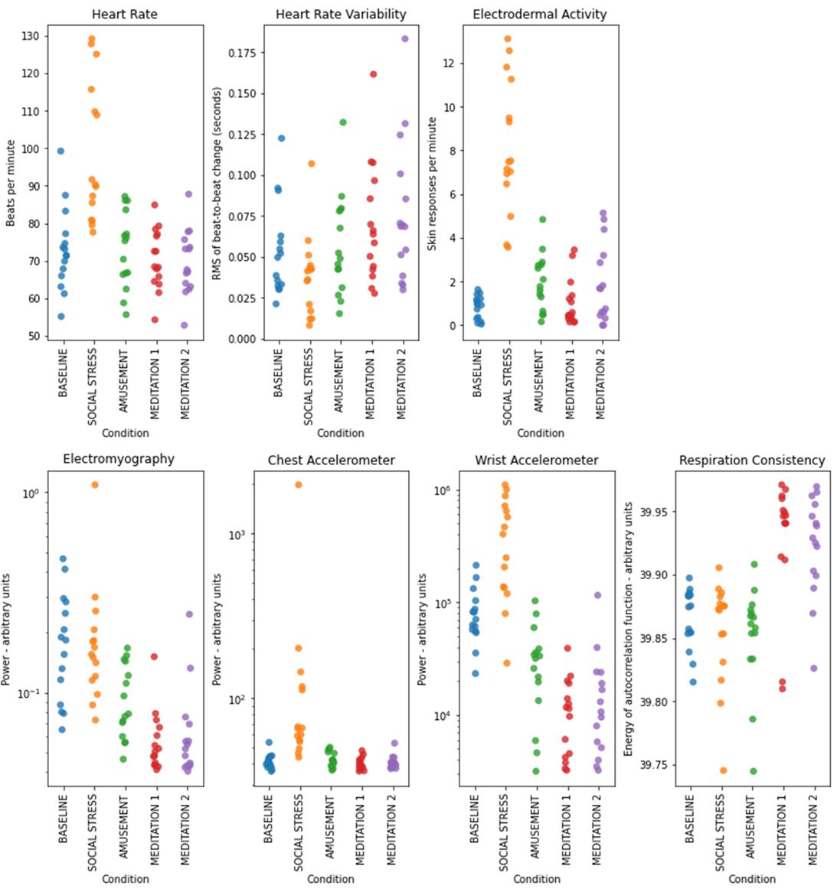

Correlation analysis including all conditions did not reveal anything surprising. With physiological values as shown below, heart rate inversely correlated with heart rate variability, as is expected, and heart rate positively correlated with galvanic skin response rate. These inverse correlations are characteristics of the balance between the two branches of the autonomic nervous system and do not appear to change with different task segments. The inverse correlation between heart rate and heart rate variability is at least in part an artifact of computation, as the absolute change between subsequent interbeat intervals would typically be smaller (lower variability) if the intervals are shorter (higher heart rate).

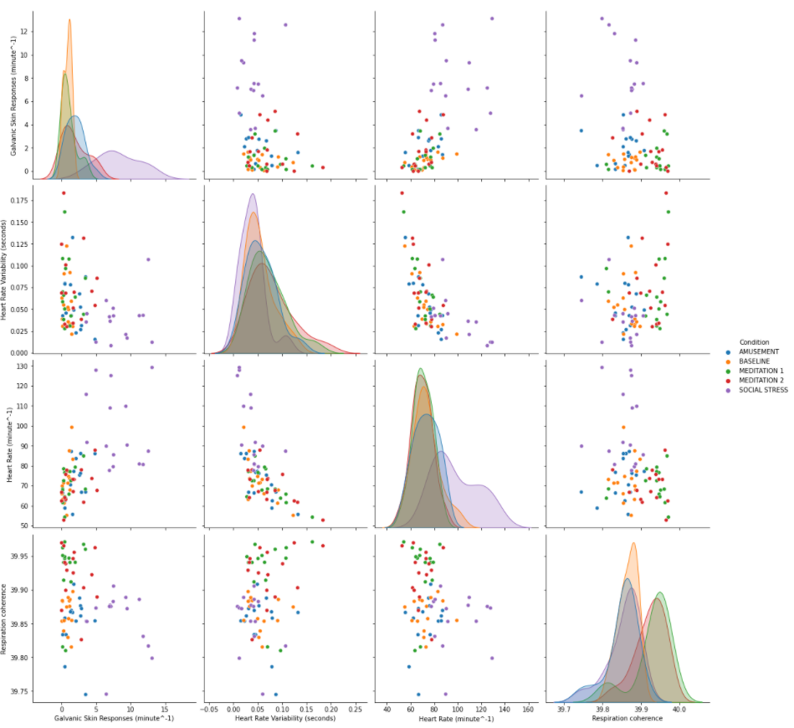

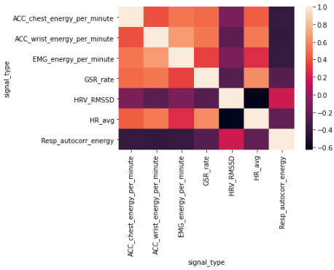

**Feature selection**

Feature selection was done by first including most physiological variables, a few psychological self-report variables, and some subject-level variables (transformed with dummy encoding or one-hot encoding as appropriate), then removing physiological features associated with task requirements.

For example, an initial random forest model with the identity of the task segment as the target identified social stress segments with 100% accuracy, but a feature importance analysis revealed that this model primarily utilized measures like movement and muscle activity, which would necessarily be higher in a social interaction task than in resting tasks. When movement and muscle activity features were removed, social stress was predicted with 88% accuracy instead of 100%, and the new feature importances focused instead on autonomic nervous system indicators like galvanic skin responses, heart rate, and heart rate variability. When a final random forest model without self-report psychological variables, social stress accuracy dropped to 75%.

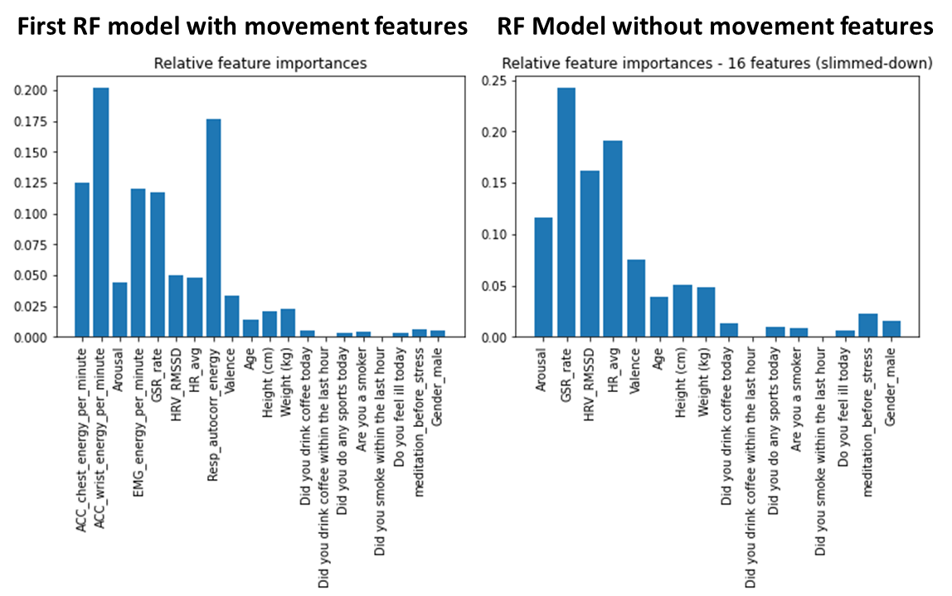

**Modeling**

Modeling focused on mind-body interactions during the social stress task segment. The first goal was to identify effects of meditation with respect to autonomic nervous system arousal and subjective self-reported arousal and valence during social stress. The first step was to perform dimensionality reduction on physiological features related to autonomic activity. Principal component analysis was performed on galvanic skin response rate, heart rate variability, heart rate, and the subject-level variables age, height, weight, and gender. The 2nd component (shown below as component 1), which accounts for approximately 30% of variability, appears to best reflect autonomic arousal of the sympathetic nervous system.

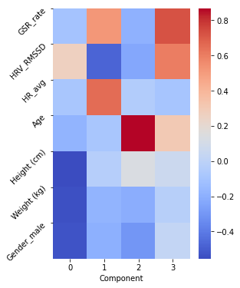

As would be expected for a biological stress response, higher sympathetic arousal correlates to subjective arousal and to negative affective valence.

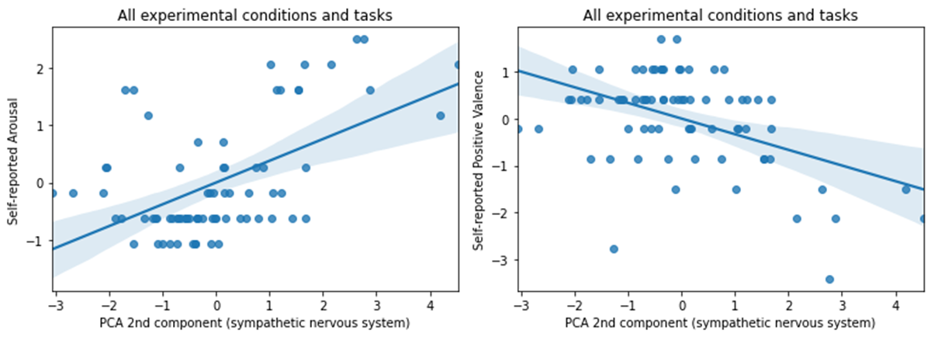

Interestingly, these effects appeared to result from dynamics during the social stress task segment. The correlations were not clearly present in the other task segments. This is a notable finding because it is consistent with a view of stress response systems as recruited by stimuli rather than always being active.

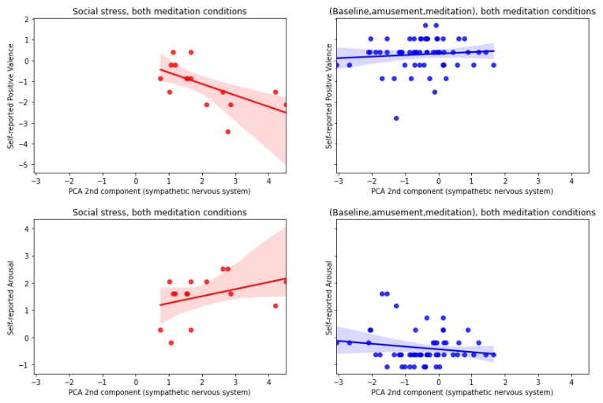

Effects of meditation were studied by using a support vector classifier to predict whether the participant had a meditation task segment before social stress. The PCA component representing the sympathetic nervous system was one feature, and self-reported valence or self-reported arousal were other features. At first, only 2 features were used at a time for the sake of visualization and interpretability.

It appears that the strongest predictor of prior meditation was the relationship between physiological arousal (sympathetic nervous system activity) and psychological arousal, with meditators achieving higher subjective arousal for a given level of physiological arousal. When a t-test examined the distance from the decision boundary compared by meditation condition, the resulting p-value was p=0.002, suggesting a significant effect of meditation and/or amusement on psychobiological stress responses to social stress in the near future.

The effect of meditation on the association of sympathetic nervous system activity with affective valence was less accurate.

However, leaving physiological arousal out completely and predicting meditation based on the association of self-reported arousal and valence was relatively robust. There is an simple interpretation with the latter: during social stress, higher levels of subjective arousal without reduction in affective valence can be achieved after meditation compared to participants that did not meditate before social stress.

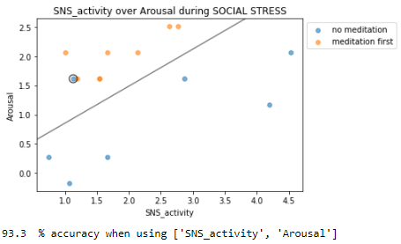

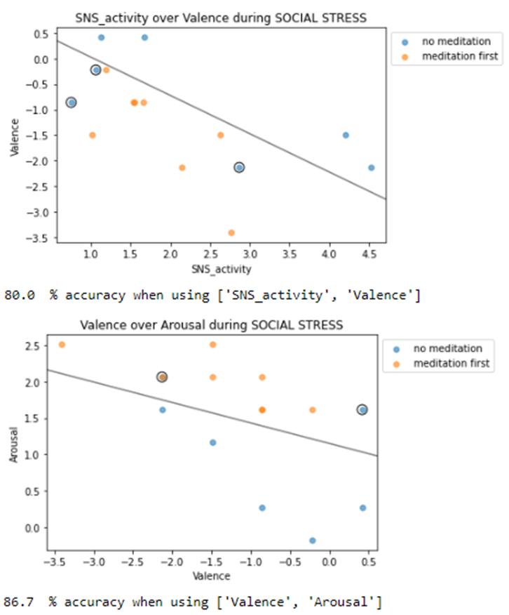

Here is one final visual representation, showing the valence-arousal space with sympathetic nervous system activity shown as size of the point. SNS activity seems correlated with valence rather than arousal, which could explain why valence and SNS activity together are not as good predictors as arousal and SNS activity.

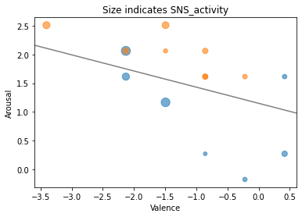

For a more formal model score, all 3 features (valence, arousal, and SNS activity) were inserted into a support vector classifier model (regularization parameter C=1) with 12 training instances and 3 test instances, and this was repeated 1000 times with random train-test splits to obtain accuracy scores. The overall accuracy was 83.1%. The class accuracy was 64.7% for non-meditators and 99.3% for meditators. The class accuracy imbalance might mean that a minority of non-meditators are already psychologically grounded based on other coping strategies, while meditation consistently grounds people regardless of their own coping strategies.

This scoring procedure was repeated with a logistic regression model (regularization parameter C=10) with the same 3 features. This logistic regression was marginally better than the support vector classifier, with an overall accuracy of 84.3%, a non-meditators class accuracy of 65.9%, and a meditators class accuracy of 100%.

**Recommendations**

Meditation and/or comedy may be effective at increasing presence of mind and reducing impacts of stress during stressful social experiences.

**Future directions**

A fraction of non-meditators showed physiological-psychological dynamics that resembled meditators, meaning that some non-meditators are already coping well. It would be beneficial to identify predictors of optimal physiological-psychological dynamics. These predictors could hypothetically be used by a real-time tracking algorithm in order to advise a person to meditate shortly before expected social stress, such as giving a presentation or engaging in an interview.

References

Allen, A. P., Kennedy, P. J., Dockray, S., Cryan, J. F., Dinan, T. G., & Clarke, G. (2017). The Trier Social Stress Test: Principles and practice. *Neurobiology of Stress*, *6*, 113–126. https://doi.org/10.1016/j.ynstr.2016.11.001

Schmidt, P., Reiss, A., Duerichen, R., & Van Laerhoven, K. (2018). Introducing WeSAD, a multimodal dataset for wearable stress and affect detection. *ICMI 2018 - Proceedings of the 2018 International Conference on Multimodal Interaction*, 400–408. https://doi.org/10.1145/3242969.3242985